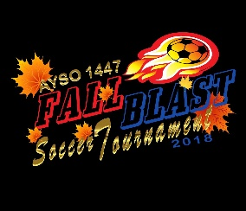 |  | 2019 AYSO Fall Blast Tournament  Referee Information Form
I plan to bring a referee team to the tournament Y/N: |  |  |  |  |  |  |  |  |  |  |  |  |  |  |  | Referee Information Form Date:
Region: |  |  |  |  |  | Team Name:

Coach Name:
Age Division: |  |  |  | 9U |  |  |  | 10U |  |  | 12U |  |  | 14U |  |  |  | 19U |  | Boys |  |  | Girls |  |  | Coed

Referee Team Contact Person
Name: |  | Email Address:
Day Phone: |  | Evening Phone:
Provide the following information for each referee.
- For “Badge Level”, insert R = Regional, I = Intermediate, A = Advanced, N = National. Also the date they were certified at that level.
- In each box under “Center/Assistant/Boys/Girls”, provide the highest level they are competent to referee (e.g. BU-10, GU-12, etc.)
- In “Player on Team”, indicate if the referee has a child who is playing in the tournament on this team.

 | Referee Name | Badge Level | Certifica-  tion Date | Center |  | Assistant |  | Player on Team (Y/N) | Home Phone/ Email
 |  |  |  | Boys | Girls | Boys | Girls
1
2
3
4

Regional Referee Administrator’s Name |  | Phone Number |  | Email
By my signature below, I certify that all referees listed are trained and Safe Haven certified AYSO referees and qualified for officiating U-10 through U-19 games as indicated above.
RRA Signature and date (Blue ink please)

Area Referee Administrator’s Name |  | Phone Number |  | Email
By my signature below, I certify that all referees listed are trained and Safe Haven certified AYSO referees.
ARA Signature and date (Blue ink please)

